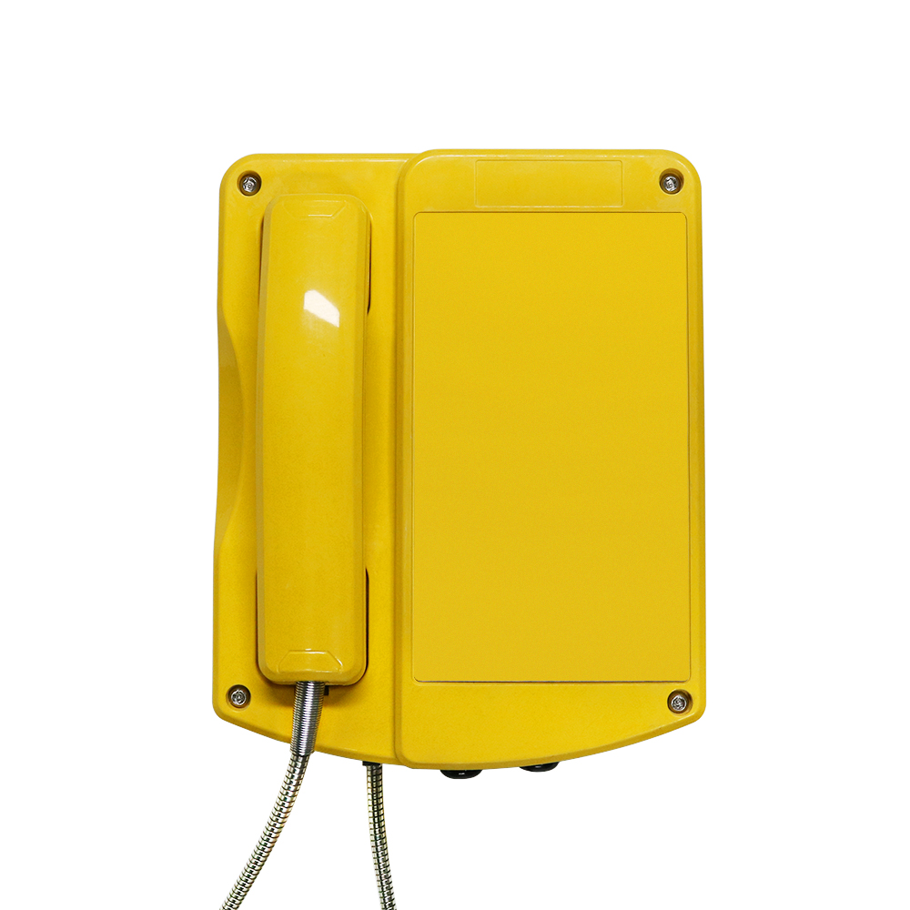  Overview:  The JREX106-SIP are designed to provide safe,reliable communication in hazardous areas.the telephones sets were developed for operation in the petrochemical industrial,usually used in production,transportation and refining of oil,natural gas,coal and etc.The housing is made of impact and shock-resistant GRP and even resistant to acids, alkali and lubricants. Its robust design represents a perfect“packaging” for the latest requirements for VoIP telephones combined with proven reliability for critical mission communications and high safety applications. It is designed to provide ultimate user comfort on the basis of industrial standards and decades of market leading expertise and know-how.  II 2G Ex e ib [ib] mb IIC T4 Gb  II 2D Ex ib [ib] tb IIIC T135 °Db  -40 °C ≤ Ta ≤ +60 °C/+40°C  Zone 1,2,22 | FEATURES and BENEFITS  •PoE 802.3af enabled (Power-over-Ethernet) or alternate power source  •Compatible with most SIP-based IP-PBX servers that comply with SIP RFC 3261  •High impact thermoset resin industrial housing and ergonomic heavy duty handset-IP-66 compliant  • Network web management  •Fully configurable through any internet browser or the on-board display.Static IP address provisioning or DHCP  • Product self diagnostic testing available through web interface  •Network adjustable earpiece volume and microphone sensitivity  • Network downloadable firmware  •Remote programming-allows you to manage your network from a central location  • Corrosion resistant hardware  • Noise canceling microphone  • Magnetic reed hook switch to reduce parts subject to wear  • Direct dial to an assigned location  • Programmable auto hang-up timer  • Hearing-aid compatible (HAC) receiver  • Available with vandal resistant armored handset cord or heavy duty curly handset cord  • Two M20 gland entries  • Field repairable by authorized personnel  APPLICATIONS  • Refineries • Sewage Plants  • Power Generation Facilities • Drilling Rigs  • Pulp and Paper Mills • Hydroelectric Facilities  • Food Processing Plants • Warehouses  • Chemical Plants • Mines  • Material Sites • Greenhouses  • Cement Plants and more
OVERALL DIMENSIONS
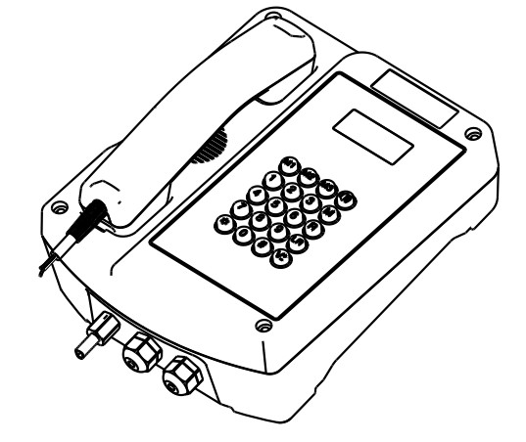 | 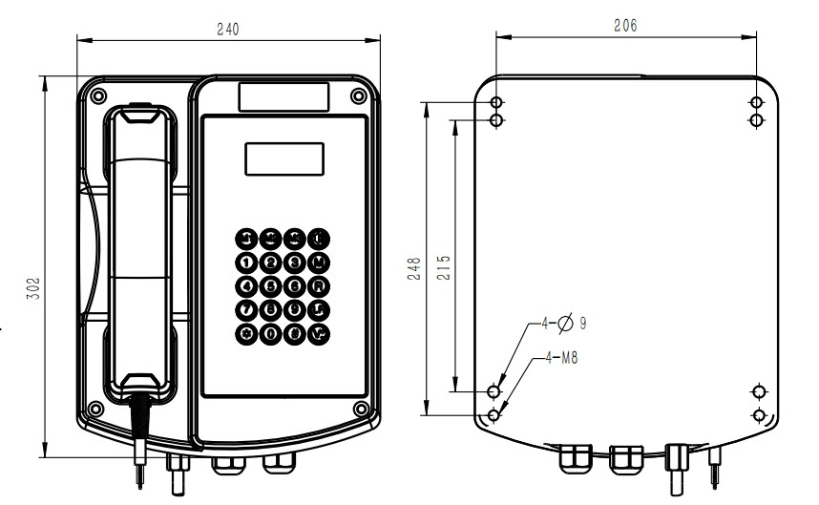
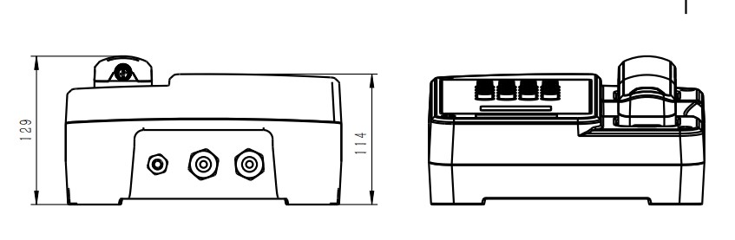 | 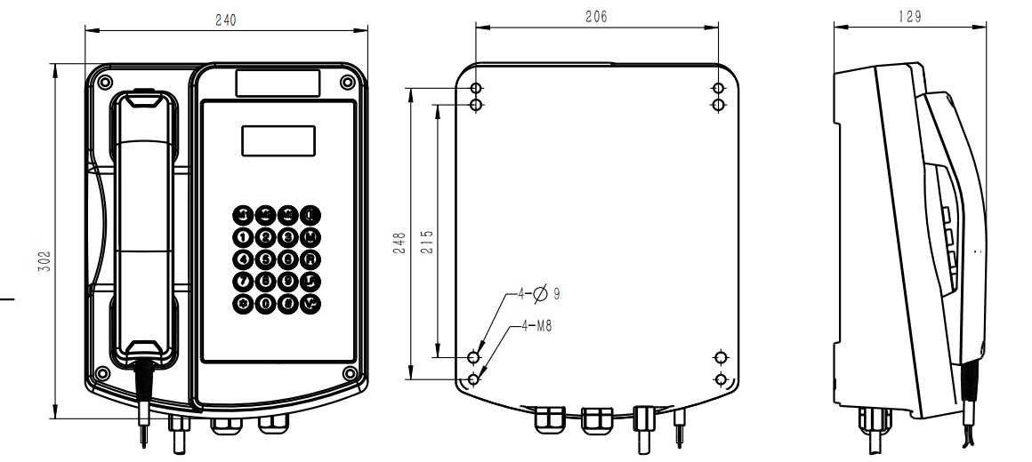

ENGINEERING SPECIFICATION:  Electrical Performance:  Network Rate 10/100 Mbps  Protocol SIP (RFC 3261 Compliant)  Codec G.711A/u,G.7231 high/low,G.729,G.722  Power Requirements Power over Ethernet according to IEEE 802.3af over spare cable pair or external supply, 12V DC  Power consumption PoE (class0)： 2.5 W  Connection Direct connection to LAN or WAN via RJ45 connector  M.T.B.F. In excess of 50,000 hours using  Lightning /Transients Protection to ITU-T k.21 enhanced levels  Mechanical Specifications  Hook Switch ( Cradle Switch ) Life>1 000 000 Operations  Housing Material High Impact Glass fibre-reinforced polyester  Handset Material High Impact Thermoset Resin Compound  Mounting Desk or Wall  Ringing volume: 95dB(A)in 1m distance  Microphone Noise Canceling Electret microphone  Receiver Hearing Aid Compatible (HAC)  Wiring Access: 2xM20 Cable Gland Entry Points  Net Weight 6.5kg  Shipping Weight 7.5kg  Unit Dimensions (L x W x D)302x240x129(mm)  Shipping Dimensions (L x W x D)405x280x170(mm)  Packaging materials pearl cotton,carton | Environmental Conditions  Corrosion Resistant & Dustproof Full Gasket Faceplate  Operating Temperature -45˚ to +70˚C  Ingress Protection Rating IP66 according to EN60529  Impact protection IK09 according to EN50102  Humidity 0 to 95% RH  Approval  This mark indicates compliance with the:  Radio & Telecommunications Terminal Equipment Directive  2004/108/EC    This mark indicates compliance with the:  FCC Part 15 Subpart B Class B    This mark indicates compliance with the:  II 2G Ex e ib mb IIC T4 Gb  II 2D Ex ib [ib] tb IIIC T135 °Db
ACCESSORIES:

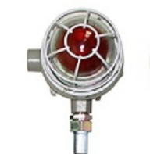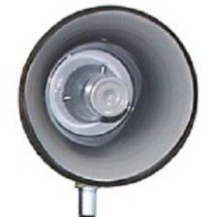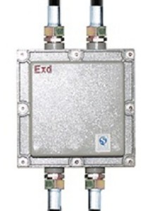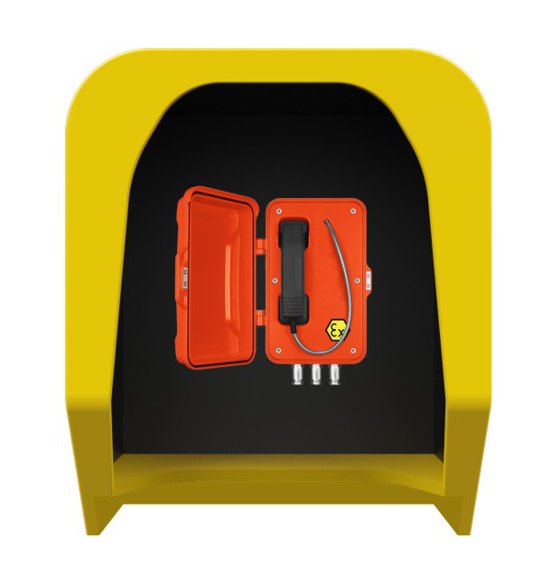
Explosion Proof Beacon JR-EB-01 Explosion Proof Horn JR-EH--01 Explosion Proof Junction Box Acoustic hood JR-TH-01

